Reportable Event User Manual

A step by step navigational process

November 2013

Prepared by: FEi Systems

Contents

1 Access Reportable Event 1

2 Add Reportable Event 2

2.1 I. Event Report 4

2.2 II. Intervention & Action Plan 9

2.3 III. DHMH Triage 11

2.4 IV. DHMH Review 14

2.5 Progress Notes 17

3 Discard Reportable Event 18

4 Print Reportable Event 19

5 Reportable Event My List 20

# Access Reportable Event

To access reportable Event, you must login as a permitted user:

1. Log in as the permitted user
2. Search for client under *Clients* tab using “**Case**” search
3. Click **Client Summary** for client

1. Enter client information and click "Cases" button
2. Click "Client Summary" link

1. Click **Case Management** from left navigation, then click “Reportable Events”

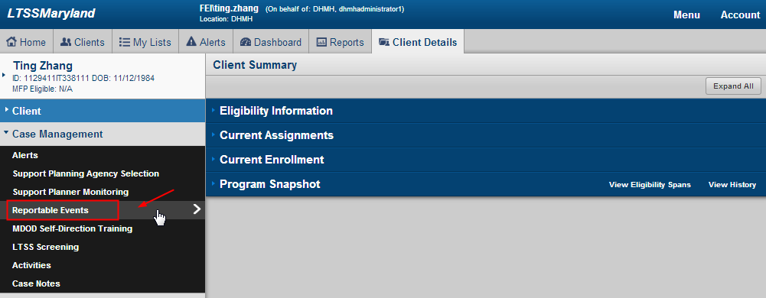

1. LTSS will bring you to Reportable Events - List page

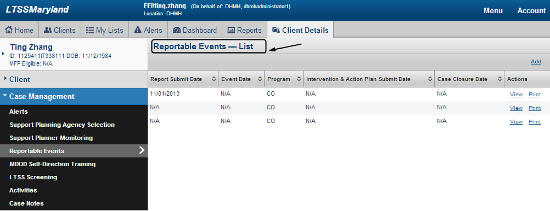

# Add Reportable Event

To add reportable Event, you must login as a permitted user:

1. Access Reportable Event
2. Click “Add” form Reportable Events – List page

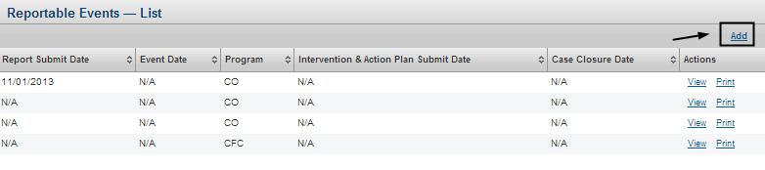

1. If client doesn’t have active enrollment or application, LTSS will ask you to confirm continue or cancel. Click “Yes” to continue, click “No” to cancel

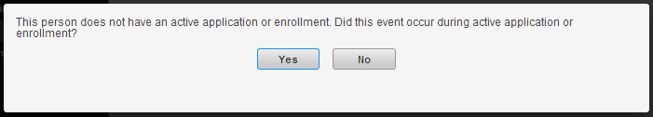

1. Check applicable program type(s) and click “save”

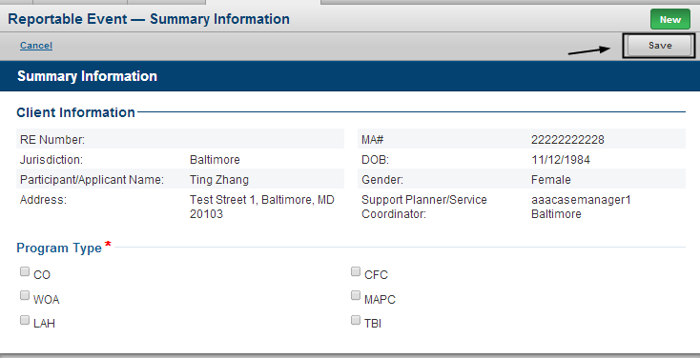

1. An In Progress reportable event is created and you can start entering detailed reportable event information

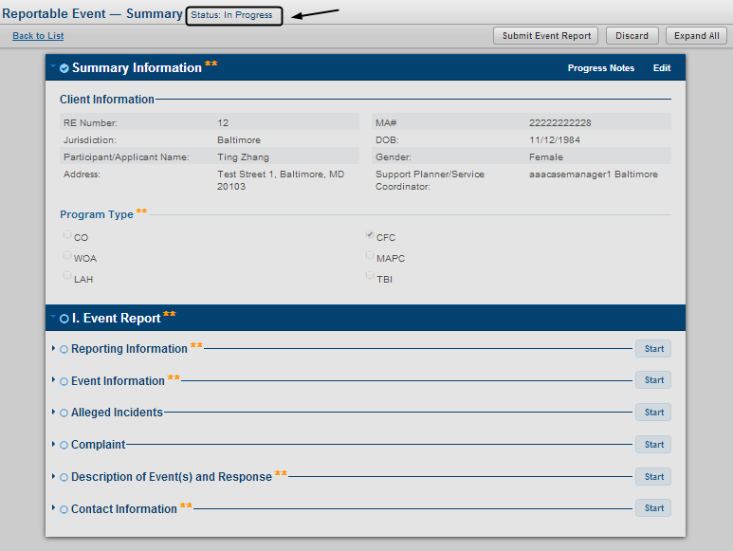

## I. Event Report

### Add I. Event Report

The “I. Event Report” section is automatically initiated after selecting program type(s). To enter Event Report information, you must login as permitted user and select an “In Progress” record:

1. Access an “In Progress” reportable event record and click “Start” of a sub-section of “I. Event Report”

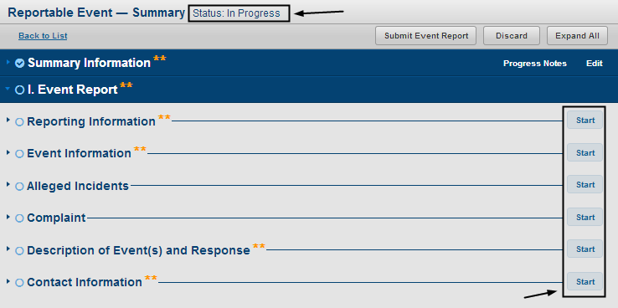

1. Enter information for selected sub-section and click “Save”

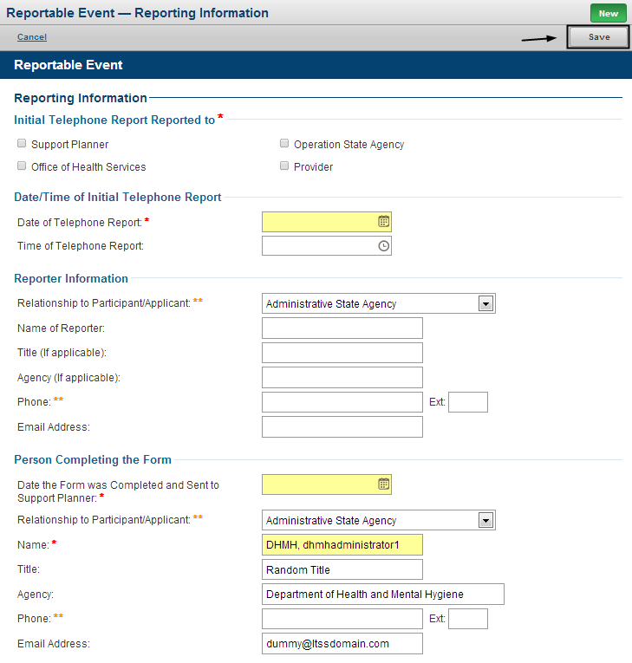

1. LTSS will bring you back to RE summary page and you can check status of each section:  indicates a complete section;  indicates an In Progress section;  indicates an un-started section

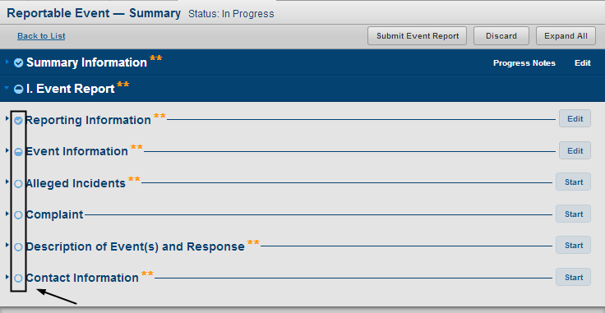

### Edit I. Event Report

To edit “I. Event Report”, you must login as permitted user and select an “In Progress” record

1. Access an “In Progress” reportable event and click “edit” of an In progress section

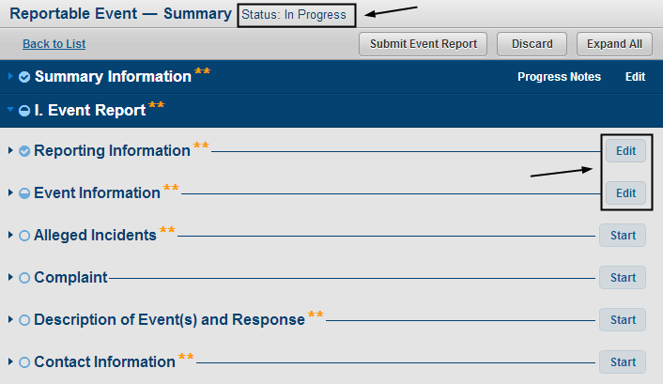

### Submit I. Event Report

To submit “I. Event Report”, you must login as permitted user and complete all sub-sections of “I. Event Report”

1. Access an “In Progress” reportable event and complete all sub-sections of “I. Event Report”
2. Click “Submit Event Report”

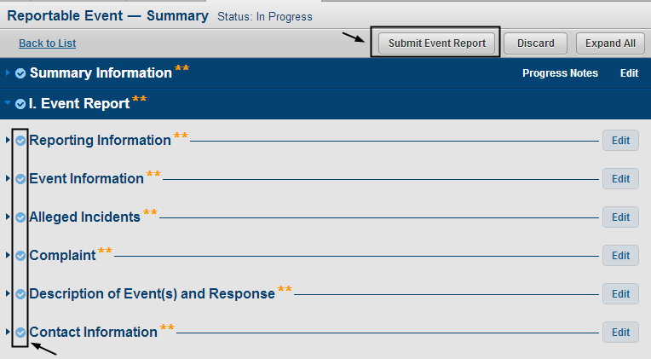

1. If you are DHMH user, LTSS will prompt you to choose alerting support planner or not. Click “Yes” to submit and alert support planner; click “No” to submit and without alerting support planner; click “cancel” to cancel submission.

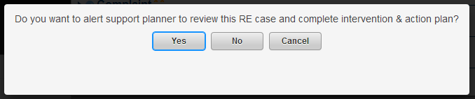

1. Once submitted, the reportable event status will be changed to “Event Report Submitted” and “II. Intervention and Action Plan(s)” and “III. DHMH Triage” are automatically initiated

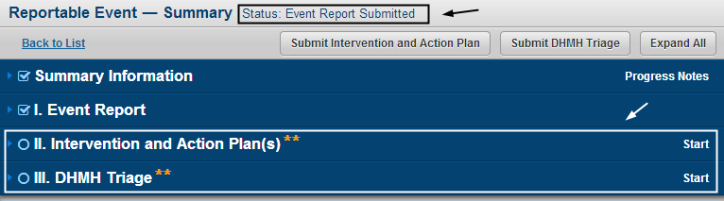

### Discard I. Event Report

Please refer to “3 Discard Reportable Event”.

## II. Intervention & Action Plan

### Add II. Intervention & Action Plan

The “II. Intervention & Action Plan(s)” section is automatically initiated after submitting “I. Event Report”. To enter Intervention & Action Plan information, you must login as permitted user

1. Access a reportable event record and click “Start” of “II. Intervention & Action Plan(s)”

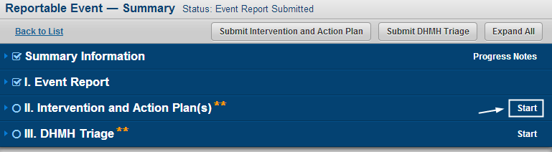

1. Enter Intervention & Action Plan information and click “Save”

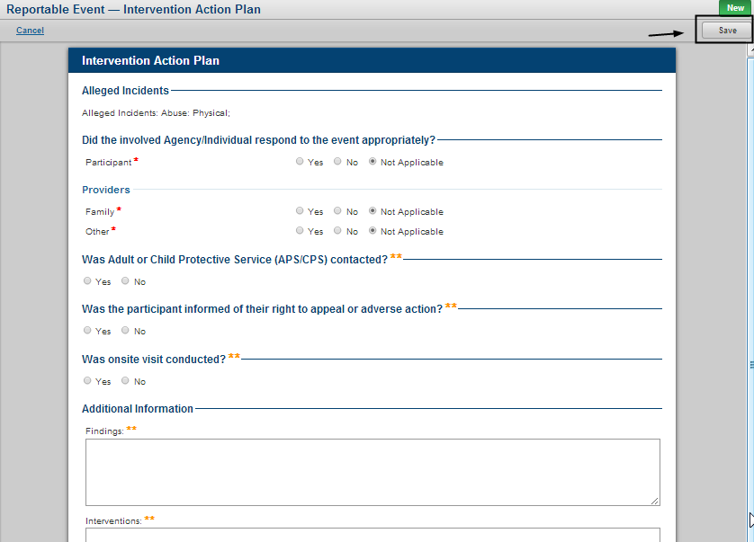

### Edit II. Intervention & Action Plan

To edit “II. Intervention & Action Plan”, you must login as permitted user and select an “open” reportable event record[1]

1. Access an open reportable event record and click “Edit” of “II. Intervention & Action Plan(s)”

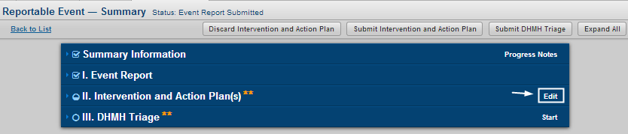

1. Edit Intervention & Action Plan information and click “Save”

### Submit II. Intervention & Action Plan

To submit “II. Intervention & Action Plan”, you must login as permitted user and select an “open” reportable event record

1. Access an open reportable event record and complete “II. Intervention & Action Plan”
2. Click “Submit Intervention and Action Plan”

Access an open reportable event record and complete “II. Intervention & Action Plan”;
Click “Submit Intervention and Action Plan”


### Discard II. Intervention & Action Plan

To discard “II. Intervention & Action Plan”, you must login as permitted user and select an “open” reportable event record. Please note once “II. Intervention & Action Plan” is submitted, you can no longer discard it.

1. Access an open reportable event record and click “Discard Intervention and Action Plan”

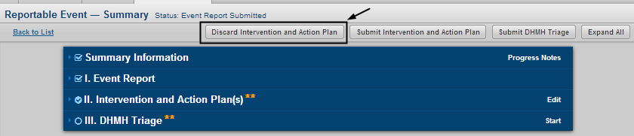

1. Enter comments for discard, then click “Yes” to complete discard. You can also click “No” to cancel

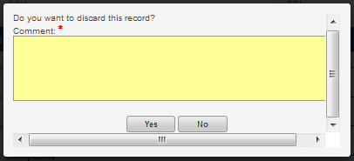

## III. DHMH Triage

### Add III. DHMH Triage

The “II. DHMH Triage” section is automatically initiated after submitting “I. Event Report”. To enter DHMH Triage information, you must login as permitted user

1. Access a reportable event record and click “Start” of “III. DHMH Triage”

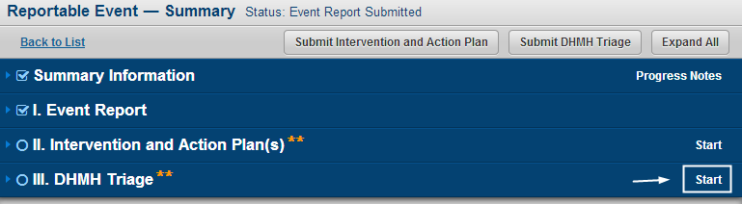

1. Enter DHMH Triage information and click “Save”

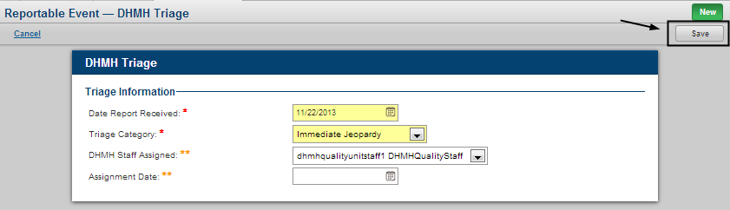

1. Please note that if Triage Category = “No Action Necessary”, the reportable event record will be closed automatically upon submission of “III. DHMH Triage”

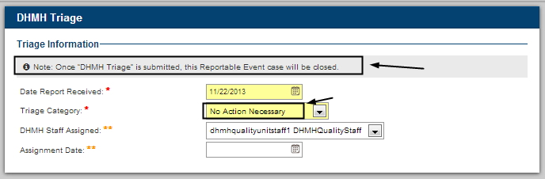

### Edit III. DHMH Triage

To edit “III. DHMH Triage”, you must login as permitted user and select an “open” reportable event record

1. Access an open reportable event record and click “Edit” of “III. DHMH Triage”

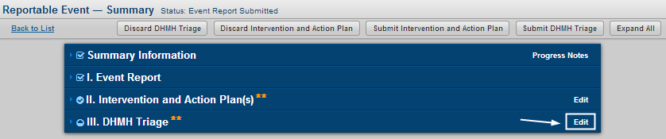

1. Edit DHMH Triage information and click “Save”

### Submit III. DHMH Triage

To submit “III. DHMH Triage”, you must login as permitted user and select an “open” reportable event record

1. Access an open reportable event record and complete “III. DHMH Triage”
2. Click “Submit DHMH Triage”

Access an open reportable event record and complete “III. DHMH Triage”;
Click “Submit DHMH Triage”


1. Once submitted, the reportable event status will be changed to “Pending DHMH Review” and “IV. DHMH Review” is automatically initiated

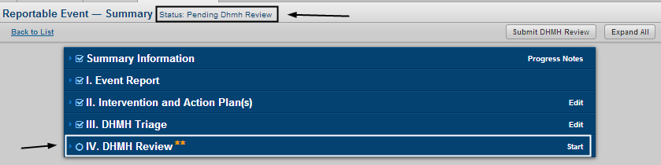

### Discard III. DHMH Triage

To discard “III. DHMH Triage”, you must login as permitted user and select an “open” reportable event record. Please note once “III. DHMH Triage” is submitted, you can no longer discard it.

1. Access an open reportable event record and click “Discard DHMH Triage”

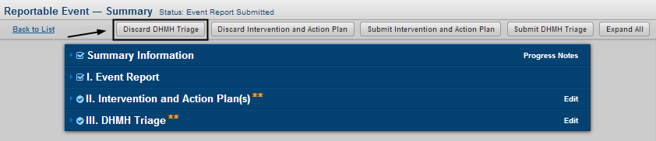

1. Enter comments for discard, then click “Yes” to complete discard. You can also click “No” to cancel



## IV. DHMH Review

### Add IV. DHMH Review

The “IV. DHMH Review” section is automatically initiated after submitting “III. DHMH Triage”. To enter DHMH Review information, you must login as permitted user and choose a “Pending DHMH Review” record

1. Access a “Pending DHMH Review” reportable event record and click “Start” of “IV. DHMH Review”

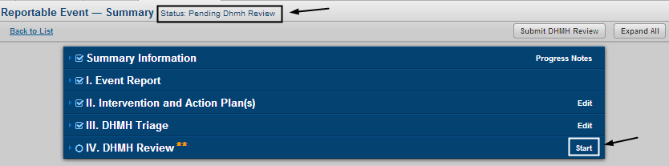

1. Enter DHMH Review information and click “Save”

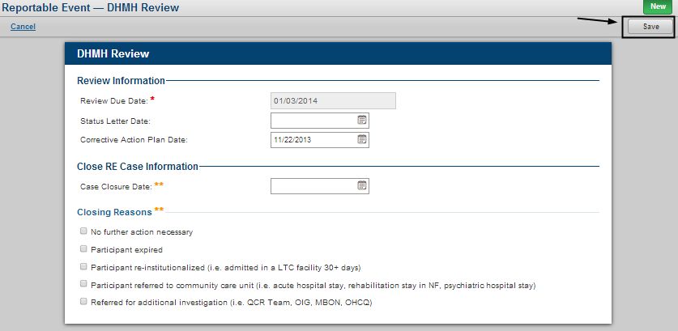

### Edit IV. DHMH Review

To edit “IV. DHMH Review”, you must login as permitted user and select a “Pending DHMH Review” reportable event record

1. Access a “Pending DHMH Review” reportable event record and click “Edit” of “IV. DHMH Review”

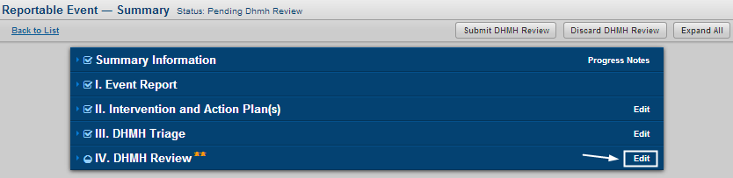

1. Edit DHMH Review information and click “Save”

### Submit IV. DHMH Review

To submit “IV. DHMH Review”, you must login as permitted user and select a “Pending DHMH Review” reportable event record

1. Access an open reportable event record and complete “IV. DHMH Review”
2. Click “Submit DHMH Review”

Access an open reportable event record and complete “IV. DHMH Review”;
Click “Submit DHMH Review”


1. Once submitted, the reportable event status will be changed to “Closed” and everything is locked and no longer editable except progress notes.

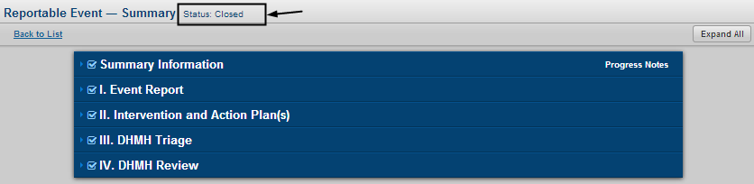

### Discard IV. DHMH Review

To discard “IV. DHMH Review”, you must login as permitted user and select a “Pending DHMH Review” reportable event record. Please note once “IV. DHMH Review” is submitted, you can no longer discard it.

1. Access a “Pending DHMH Review” reportable event record and click “Discard DHMH Review”

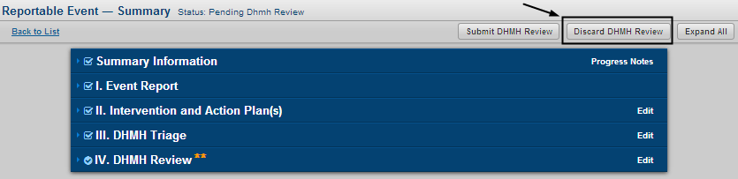

1. Enter comments for discard, then click “Yes” to complete discard. You can also click “No” to cancel



## Progress Notes

To access progress notes, you must login as permitted user choose a reportable event record to continue

1. Access a reportable event record
2. Click “Progress Notes”

Access a reportable event record and click “Progress Notes”


1. You can see all progress notes for selected record. To enter new notes, type notes in “Note” area and click “Add Progress Note”; to print progress notes, click “Print”, to exit progress notes, click “close”.

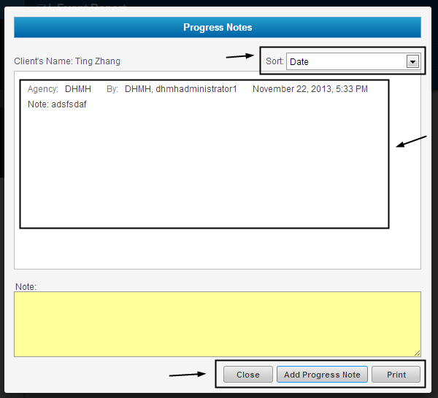

# Discard Reportable Event

To discard a reportable Event, you must login as a permitted user and choose an “In Progress” record to discard:

1. Access an “In Progress” Reportable Event record and click “Discard”

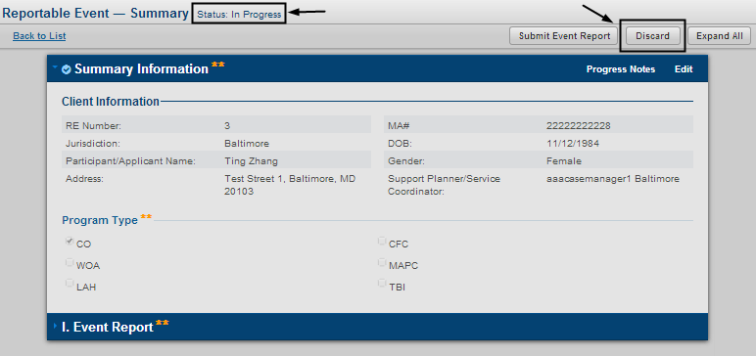

1. Enter comments for discard, then click “Yes” to complete discard. You can also click “No” to cancel



# Print Reportable Event

To print a reportable Event, you must login as a permitted user:

1. Access Reportable Event list page
2. Click “print” of a reportable event record

Access Reportable Event list page;
Click “print” of a reportable event record


1. LTSS will generate a pdf version of selected record for printing purpose

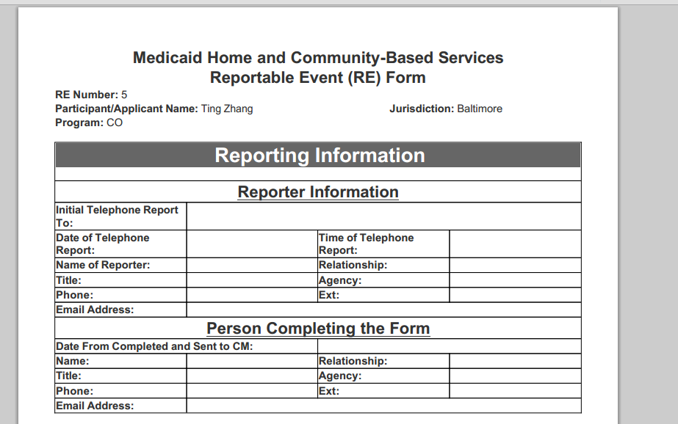

# Reportable Event My List

To access a reportable Event My List, you must login as a permitted user:

1. Login to LTSS
2. Click “My List Tab”
3. Click “My Client List” from left navigation, then click “Reportable Event”
4. Select desired option from “Show me” drop-down
5. Click “Filter”

1. Click “My List Tab”
2. Click “My Client List” from left navigation
3. Then click “Reportable Event”
4. Select desired option from “Show me” drop-down
5. Click “Filter”


1. LTSS will display searching result. You can choose one to “View” or “Print”

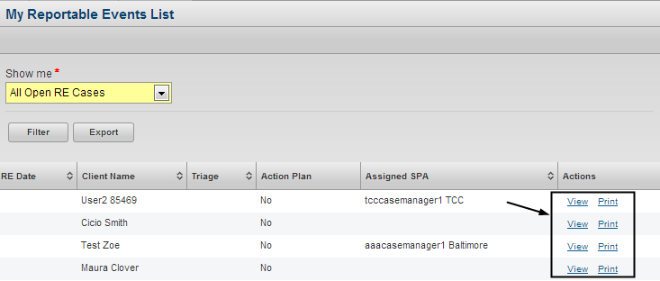

1. “Open” reportable event record refers to a RE record without submitted “IV.DHMH Review”